|  |  |  |  |  |
| --- | --- | --- | --- | --- |
| **National University of Computer and Emerging Sciences, Lahore Campus** | | | | |
| C:\Users\saif\AppData\Local\Microsoft\Windows\Temporary Internet Files\Content.Word\final design.jpg | **Course:** | **Software Design and Analysis** | **Course Code:** | **CS-3004** |
| **Program:** | **BS (Computer Science)** | **Semester:** | **Fall 2024** |
| **Duration:** | **40 Minutes** | **Total Marks:** | **20** |
| **Quiz Date:** | **27-Nov-24** | **Roll No.** |  |
| **Section:** | **BCS-5A** | **Name:** |  |
|  |  |  |  |
|  |  | | | |

**Question 1)** Identify and mention the design pattern that can make OldMediaPlayer compatible with ModernMediaPlayer. Write the missing code.  **(10 Marks)**

|  |  |
| --- | --- |
| class OldMediaPlayer {  public:  void playOldFormat(const string& file) {  cout << "Playing old format: " << file << endl;  }  };  class ModernMediaPlayer {  public:  void play(const string& file) {  cout << "Playing modern format: " << file << endl;  }  }; | **Adapter Pattern**  **Solution:**  class MediaPlayerAdapter : public ModernMediaPlayer {  private:  OldMediaPlayer* oldPlayer;  public:  MediaPlayerAdapter(OldMediaPlayer* player) {  oldPlayer = player;  }  void play(const string& file) override {  oldPlayer->playOldFormat(file);  }  }; |

**Q2)** Improve the following design using an appropriate **design pattern**: **(10 marks)**

Note: All three classes represent gifts sold by a gift shop.

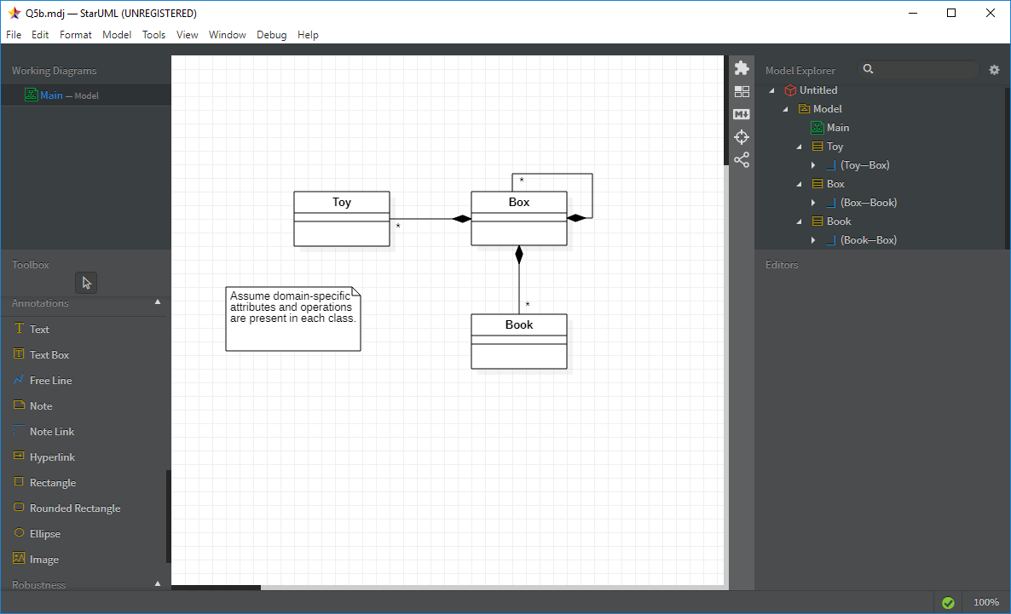

**Design Pattern Used: Composite**

